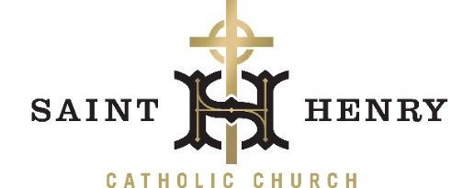

Dear Parishioners:
As Jesus began his ministry, he climbed a beautiful mountain above the Sea of Galilee and began his Sermon on the Mount. I can imagine Jesus looking directly in the eyes of his followers as he says, “You are the salt of the earth! You are the Light of the World!” Having just been called to follow Jesus, and beginning three years of close personal formation, Jesus already sets his sights upon the world!
Jesus, too, looks directly into our eyes and invites us to be “Salt for the earth and light for the world” today. We are called to be a living presence of the goodness and love of God in our world for each other in this wonderful community of St. Henry, and to let that light shine out to everyone we encounter each day. It is surely the work of the Holy Spirit and God’s own love in our hearts that enables us to do so!
I invite you to be an active participant in the life of our community by choosing a ministry or ministries that are “right for you.” (I always say if I have the time and ability and interest, that’s a good ministry for me!)
I offer you these three ways to open yourself to be “light for the world, and salt for the earth”
Prayer – Everything we have in life is a blessing from God. Consider beginning every day with a prayer of gratitude, to make us more open to recognize the gifts God has given us. Be a faithful and consistent participant especially in the celebration of the Sunday Eucharist. The Eucharist is the summit and source of our Christian lives!
Participation – As prayer allows us to discern the gifts the Holy Spirit has given to us, we can also consider how they match the needs and opportunities in our parish, and then use them in strengthening our community. Get involved! Invite others to get involved!
Generosity – As stewards we realize that all that we have comes from God. Consider how we are called to share all types of our gifts: our time, talent and treasure. We, as a parish, and a church can never be fully who God intended us to be, without each of us.
We live in a time in our world with many challenges and opportunities, but the personal call of Jesus to each of us never changes. The gift of his Holy Spirit sustains us in this journey as he promised to be with us always.
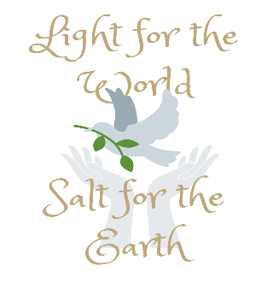
I am asking you to join us as we share the light of Christ with each other and with all those whose hearts hunger for Christ in our world today and to make a pledge to St. Henry Church and each other for the coming year of 2023.

Blessings in the Lord,
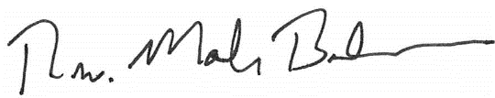
Fr. Mark Beckman
Pastor

